NAME: GAIRE ANANTA PRASAD

STUDENT ID: M24W0272

1. HTML5 code for Mathematical Operator

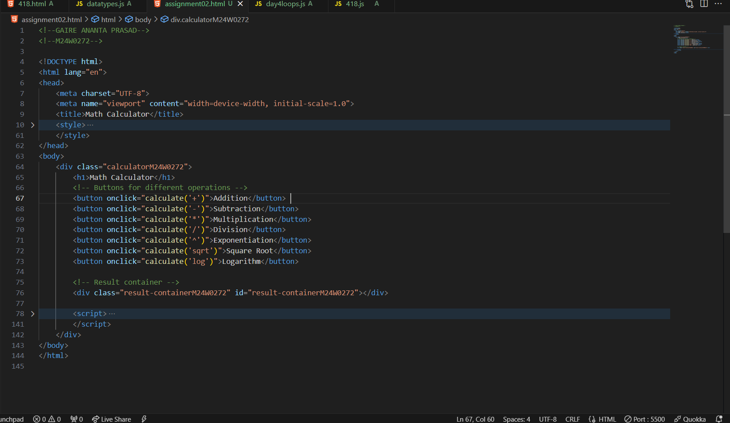

1. JAVASCRIPT code for Mathematical Operator

1. CSS for Mathematical Operator

1. Output for Mathematical Operator.

1. Showing error while condition is not matched.

